**Practice Session 6 & 7: Egf based Haskell approach and rupture directivity**

Prithvi Thakur

Given a constant rise time = 0.2 sec.

The sample space for rupture time = 0.05 – 1.5 sec with increments of 0.05 sec.

The synthetic source time function for an example rupture time of 1 sec is shown in Fig 1.



Fig. 1. Convolution of two box cars. The first figure shows the rise time of 0.2 sec and the second figure shows the rupture time of 1 sec. The third figure is the convolution source time function.

We manually pick the first S-wave arrival and cut the master and egf events from -0.5 sec to 7.5 sec around the S-wave, i.e., eight second window.

Using the above source-time function, we calculate the optimum rupture time for which the misfit between convolved egf and the master is minimum. The waveforms for the minimum misfit are shown in fig. 2.

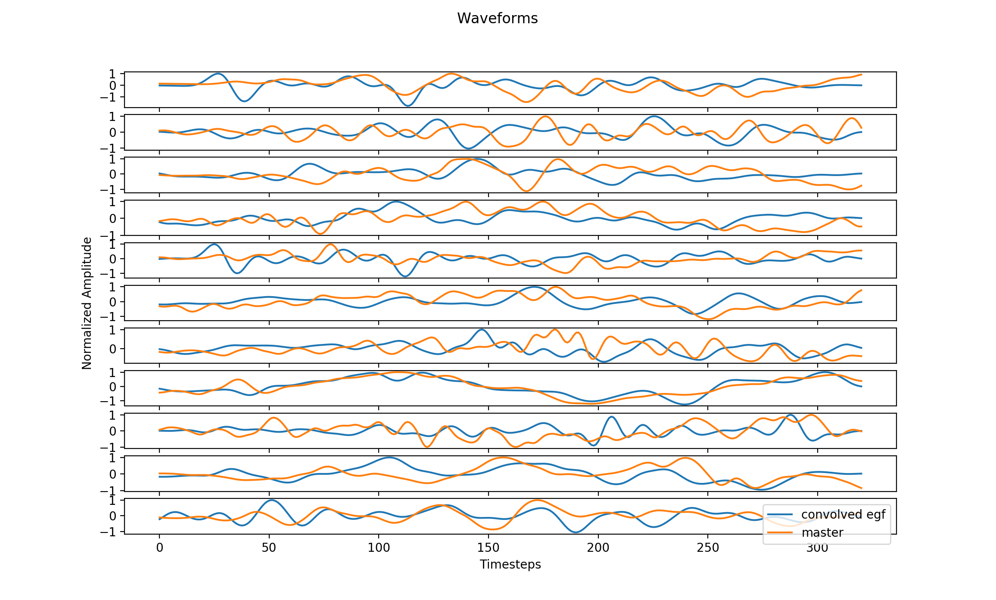

Fig. 2. Normalized waveforms for each station with the convolved egf. We see that very few stations have a good match.

Next, we show the rupture time as a function of station azimuth in Fig. 3. to see any directivity effects. We see that most of the stations are located between 0 and 180 degrees, which might create a bias in the directivity due to limited azimuthal coverage. From Fig. 3, it seems that rupture propagated from zero degrees azimuth to 180 degrees azimuth, i.e., from north to south if we ignore two outliers in rupture time at 40 degrees and at 110 degrees.



Fig. 3. Rupture time as a function of station azimuth.

**Adding a shift of 4 sec from master events waveform and modeled waveform**

For the next step, we repeat the same exercise but this time cutting the waveform from -4.5 to 11.5 sec around S-wave first arrival. The waveforms are shown in Fig. 4.

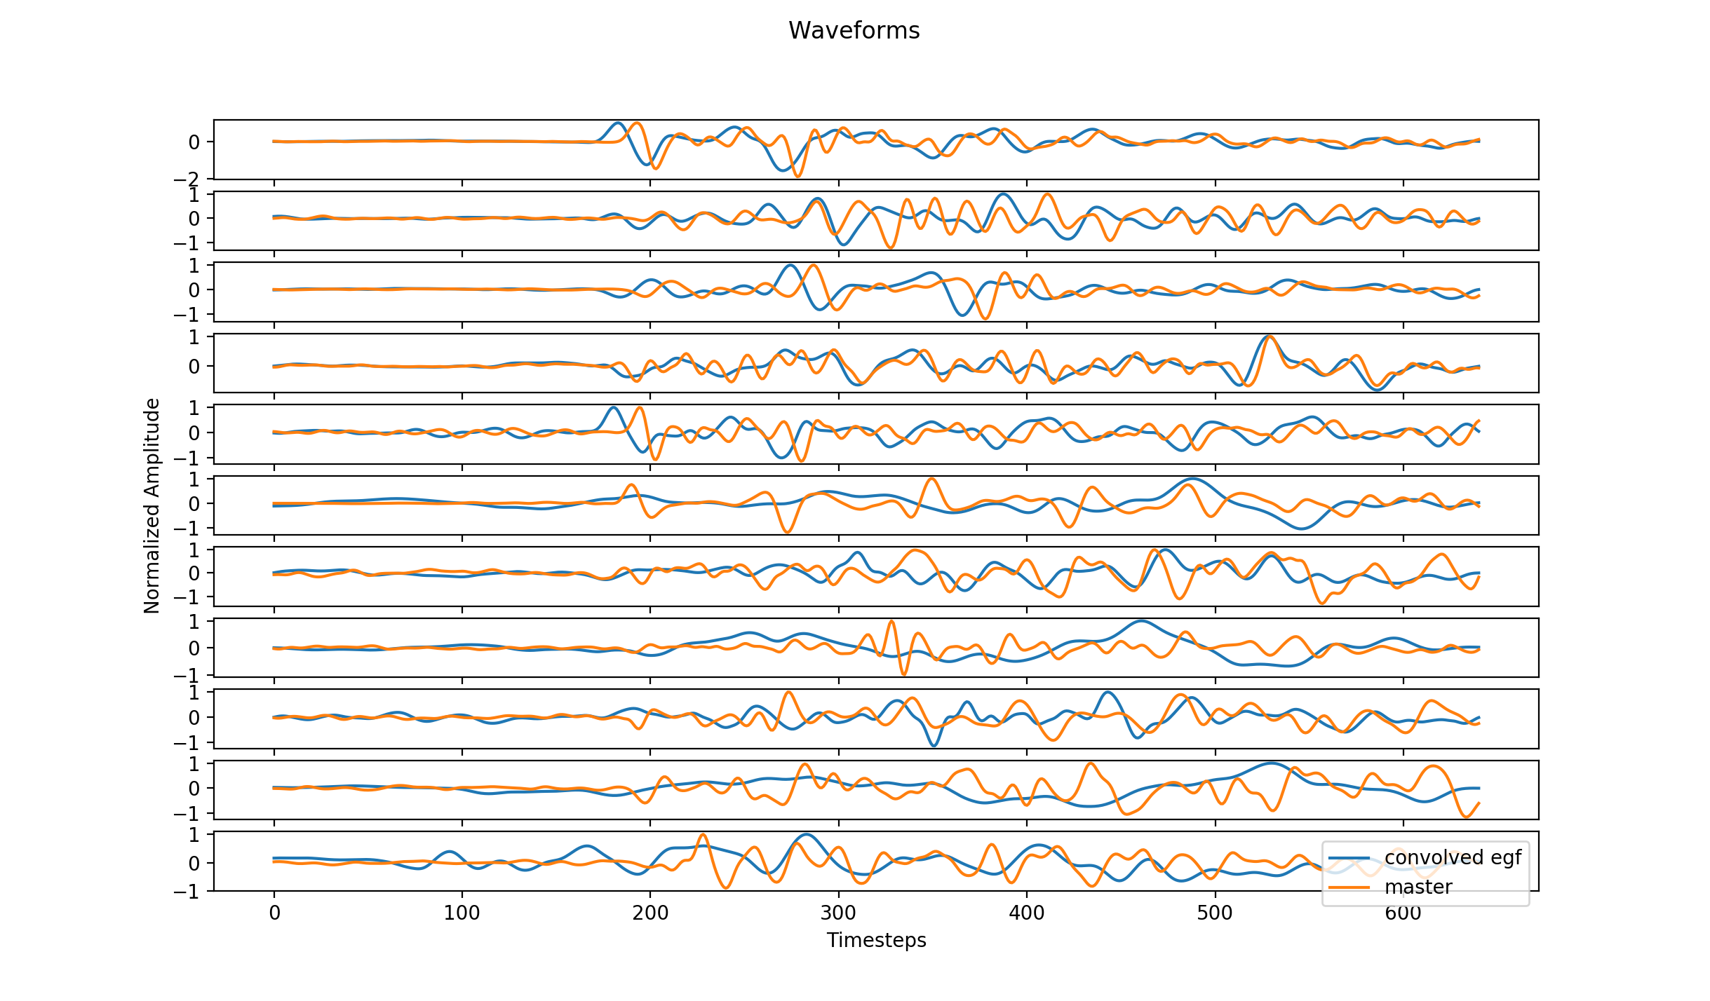

Fig. 4. Waveforms for a window of -4.5 sec to 11.5 sec from S-wave first arrival.



Fig. 5. Station azimuth vs rupture time for a longer S-wave window of -4.5 sec to 11.5 sec. This figure shows a better trend of rupture propagation from north to south.

From the Fig. 5, we can infer that the rupture time is low for near zero degrees azimuth and high for ~180 degrees azimuth, therefore the rupture must be propagating from north to south.